Exercise 7: Build website layout using Bootstrap Grid

Objectives and Outcomes

Bootstrap is a popular CSS framework that provides a grid system for building responsive website layouts. In this exercise, you use Bootstrap's grid system to build a website layout below

Exercises

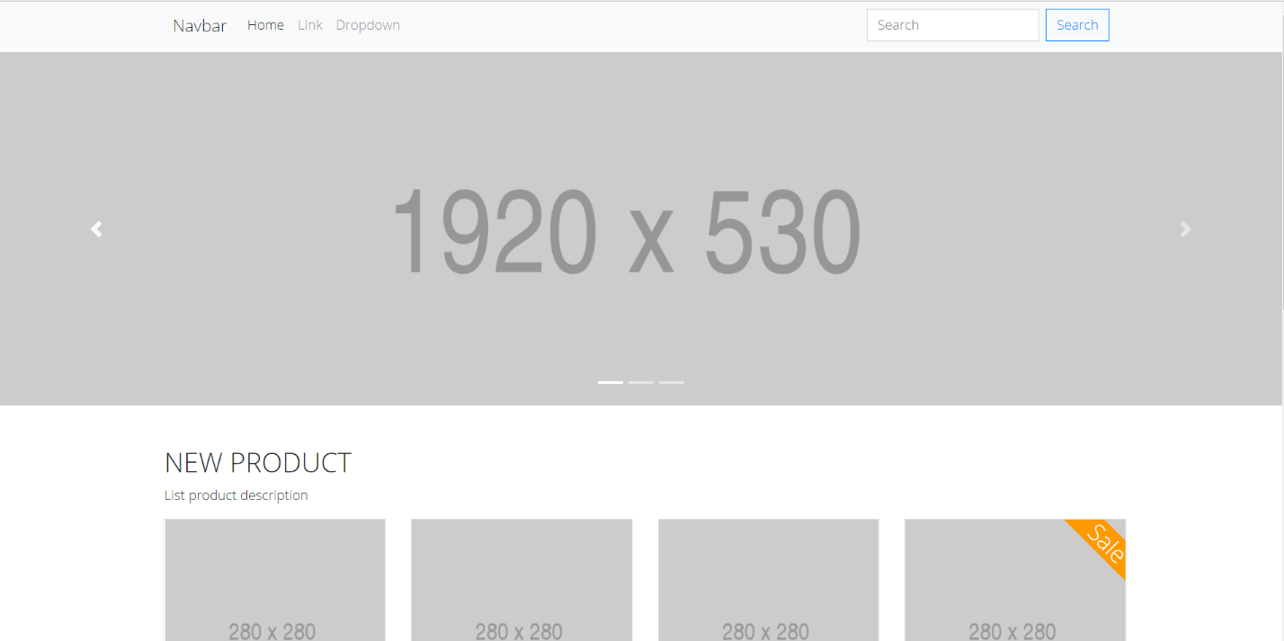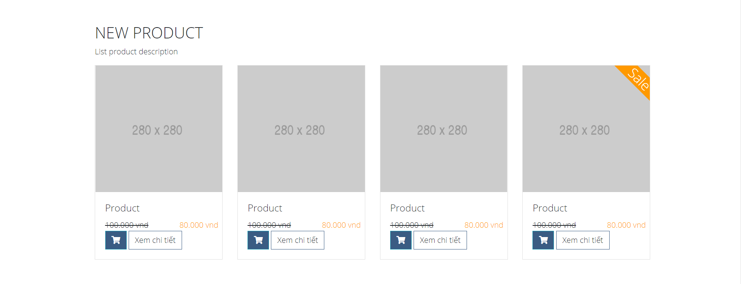

Conclusion

After learning about Bootstrap Grid, you can build a responsive website layout